

Advanced algorithms in google maps, google lens & google translate

By : Vedang Mathur



Vedang mathur

(122ME0016)

IIITDM , Kurnool

**Advanced Algorithms in Google Maps, Google Lens, and Google Translate**

**Abstract**

All the applications from the Google — Google Maps, Google Lens, Google Translate and more use these specialised algorithms to offer smooth user experiences. This review paper discusses the core algorithms behind them. Our conversation takes us through things such as route optimization, traffic prediction, and geocoding in Google Maps, image recognition, object detection, and augmented reality in Google Lens, and neural machine translation, language detection, and text-to-speech in Google Translate. This paper provides a detail overview of the technologies used behind the scenes of these popular applications.

**Introduction**

For most of us, Google has also changed the way in which we interact with the world and the information contained within it. Google Maps Full map of the world, giving guidance and local info to over a billion people Google Lens Insights and information from your camera Google Translate Instant translations to and from 100 languages This paper looks behind these services into the algorithms, -their principles, and implementations as well as their impacts.

**Algorithms in Google Maps**

**Route Optimization**

**Dijkstra's Algorithm**

Google maps employs Graph data structures for calculation of the shortest path from the source (point A) to the destination (point B). Graph data structure comprises of various nodes and multiple edges connecting these nodes. Dijkstra’s algorithm is an effective and proficient algorithm proposed by Edsger.W. Dijkstra to navigate the shortest distance and path to reach a given destination. The nodes of the graph are connected by weighted edges, which represent the distance to be traversed to reach there. Thus Dijkstra devised an algorithm to find the shortest route from the source to the destination.

**Algorithm Description**

**Initialization**

1. **Set the initial node (source) with a distance of 0** and all other nodes with an infinite distance.
2. **Create a priority queue (min-heap)** to store nodes along with their tentative distances from the source.
3. **Add the initial node to the priority queue**.

**Main Loop**

1. **Extract the node with the smallest distance** from the priority queue (initially, this will be the source node).
2. **For the extracted node**, examine all its neighbors.
3. **Calculate the distance to each neighbor** by summing the distance to the current node and the edge weight to the neighbor.
4. **If the calculated distance to a neighbor is smaller than the known distance**:
   * Update the shortest distance to that neighbor.
   * Add the neighbor to the priority queue with the updated distance.
5. **Repeat** until the priority queue is empty.

**A* Search Algorithm**

The A* Search Algorithm enhances Dijkstra’s approach by incorporating heuristics, improving efficiency. It calculates the shortest path by combining the cost to reach a node and the estimated cost from that node to the destination.

**Algorithm Description**

A* search uses two primary cost functions:

1. **g(n):** The cost to reach node n from the start node.
2. **h(n):** A heuristic estimate of the cost to reach the goal from node n.

The algorithm evaluates nodes by combining these two costs into a single function: f(n)=g(n)+h(n)f(n) = g(n) + h(n)f(n)=g(n)+h(n) where:

* g(n)g(n)g(n) is the known cost from the start node to node n.
* h(n)h(n)h(n) is the estimated cost from node n to the goal node (heuristic function).

The choice of the heuristic function h(n)h(n)h(n) is crucial for the efficiency of A*. It must be admissible, meaning it never overestimates the actual cost to reach the goal

**Turn Penalty Algorithms**

Turn penalty algorithms adjust the cost associated with transitions between road segments based on the type of turn required. The main goal is to avoid turns that may significantly slow down the journey, such as:

* Left turns at busy intersections (in right-hand traffic countries).
* Turns across multiple lanes of traffic.
* Turns onto high-speed roads.

**Real-Time Traffic Estimation**

**Historical Data Analysis**

Historical data analysis involves studying past traffic patterns to predict future traffic conditions and improve route planning. By analyzing historical data, navigation systems can provide more accurate travel time estimates and identify recurring congestion patterns.

**Data Collection**

1. **Historical GPS Data:**
   * Data from vehicles and mobile devices over time provides insights into traffic patterns.
2. **Traffic Sensor Data:**
   * Data from road sensors over extended periods.
3. **Incident Reports:**
   * Historical records of accidents, roadworks, and other incidents.
4. **Weather Data:**
   * Historical weather conditions that may affect traffic flow.

**Real-Time Data Integration**

Real-time data integration combines multiple data streams into a coherent, actionable set of information. This integration allows for dynamic route adjustments, incident detection, and traffic condition updates, thereby improving travel efficiency and safety.

**Data Sources**

**1. GPS Data**

* **Vehicles and Smartphones:** Continuous streams of location and speed data from devices with GPS capabilities.
* **Public Transport:** Real-time locations and schedules of buses, trains, and other public transport modes.

**2. Road Sensors**

* **Inductive Loop Sensors:** Embedded in the road surface to detect vehicle presence and count.
* **Radar and LIDAR:** Used to measure vehicle speed and detect traffic density.
* **Cameras:** Provide visual data for real-time traffic analysis.

**3. Mobile Network Data**

* **Cell Tower Triangulation:** Estimates device locations based on signal strength from multiple cell towers.
* **Data from Mobile Apps:** Aggregated and anonymized data from various mobile applications.

**4. Crowdsourced Data**

* **User Reports:** Information on traffic conditions, accidents, road closures, and other incidents reported by users.
* **Social Media:** Data from platforms like Twitter and Facebook, where users post about traffic and incidents.

**5. External Data Sources**

* **Weather Services:** Real-time weather conditions affecting traffic flow.
* **Municipal Authorities:** Data on roadworks, closures, and events.
* **News Feeds:** Information on major incidents affecting traffic

**Traffic Flow Models**

Traffic flow models are mathematical representations used to understand and predict the behavior of traffic on road networks. These models are crucial for traffic management, urban planning, and improving transportation systems. Here are some key types and components of traffic flow models:

**Key Components of Traffic Flow Models**

1. **Traffic Density (ρ)**: The number of vehicles per unit length of the road.
2. **Traffic Flow (q)**: The number of vehicles passing a point per unit time.
3. **Traffic Speed (v)**: The average speed of vehicles in the traffic stream.

**Fundamental Relationships**

1. **Fundamental Diagram**: Illustrates the relationship between traffic density, flow, and speed. Key insights from this diagram include:
   * At low densities, flow increases with density.
   * At high densities, flow decreases as density approaches jam density.
   * There exists an optimal density at which flow is maximized.
2. **Conservation Equation**: Reflects the conservation of the number of vehicles:



1. **Speed-Density Relationship**: Typically, speed decreases as density increases, which can be expressed in various functional forms depending on the model used.

**Geocoding and Reverse Geocoding**

**Geocoding**

**Geocoding** is the process of converting a human-readable address or place name into geographic coordinates (latitude and longitude). This process is essential for integrating location data into maps and GIS applications.

**Reverse Geocoding**

**Reverse geocoding** is the process of converting geographic coordinates (latitude and longitude) back into a human-readable address or place name. This is useful for applications that need to display location information in a more understandable format.

**Algorithms in Google Lens**

**Image Recognition**

**Convolutional Neural Networks (CNNs)**

Convolutional Neural Networks (CNNs) are a class of deep learning algorithms particularly well-suited for tasks involving image and video recognition, as well as other grid-like data. CNNs have revolutionized fields such as computer vision and are widely used in applications like image classification, object detection, and facial recognition.

**Key Components of CNNs**

1. **Convolutional Layers**
   * **Filters/Kernels**: Small matrices (e.g., 3x3, 5x5) that slide over the input data to extract features such as edges, textures, and patterns.
   * **Stride**: The step size with which the filter moves over the input data.
   * **Padding**: Adding extra borders to the input data to control the spatial dimensions of the output.
2. **Activation Functions**
   * **ReLU (Rectified Linear Unit)**: Applies a non-linear transformation by converting all negative values to zero, which helps introduce non-linearity into the model.
   * **Other activations**: Sigmoid, Tanh, and Leaky ReLU, though ReLU is most commonly used.
3. **Pooling Layers**
   * **Max Pooling**: Reduces the dimensionality by taking the maximum value in each patch of the feature map.
   * **Average Pooling**: Reduces the dimensionality by taking the average value in each patch.
   * **Purpose**: Reduces the computational load and controls overfitting by progressively reducing the spatial dimensions.
4. **Fully Connected Layers**
   * **Dense Layers**: Neurons in a fully connected layer are connected to all neurons in the previous layer, used to integrate the features extracted by convolutional and pooling layers.
   * **Activation**: Often uses softmax for classification tasks to output probability distributions over classes.
5. **Loss Function**
   * **Cross-Entropy Loss**: Commonly used for classification tasks, measures the difference between predicted and true distributions.

**Object Detection**

Object detection is a computer vision task that involves identifying and locating objects within an image or video. Unlike image classification, which assigns a single label to an image, object detection identifies multiple objects and their positions, often using bounding boxes. This task is crucial for various applications, including autonomous driving, surveillance, and augmented reality.

**Key Components of Object Detection**

1. **Bounding Box Regression**
   * Predicts the coordinates of a rectangle (bounding box) that encloses the object.
   * Common output format: (x,y,width,height)(x, y, width, height)(x,y,width,height) or (x1,y1,x2,y2)(x_1, y_1, x_2, y_2)(x1​,y1​,x2​,y2​).
2. **Object Classification**
   * Assigns a class label to the detected object within the bounding box.
   * Common output: Class probabilities or one-hot encoded vectors.
3. **Feature Extraction**
   * Uses convolutional layers to extract meaningful features from the input image.
4. **Anchor Boxes (Default Boxes)**
   * Predefined boxes of different sizes and aspect ratios used to detect objects at various scales and shapes.
   * Each anchor box is evaluated for the presence of an object.

Popular Object Detection Algorithms

• **Region-Based Convolutional Neural Networks (R-CNN)**

• **You Only Look Once (YOLO)**

• **Single Shot MultiBox Detector (SSD)**

• **RetinaNet**

• **Mask R-CNN**

**Optical Character Recognition (OCR)**

Optical Character Recognition (OCR) is a technology used to convert different types of documents, such as scanned paper documents, PDF files, or images taken by a digital camera, into editable and searchable data. OCR technology extracts and recognizes characters from printed or handwritten text within images, translating them into machine-readable text.

**Key Components of OCR**

1. **Image Preprocessing**
   * **Noise Reduction**: Removes unwanted noise to enhance image quality.
   * **Binarization**: Converts grayscale images to binary images (black and white), often using thresholding techniques.
   * **Deskewing**: Corrects any tilt or misalignment in the scanned images.
   * **Normalization**: Standardizes the size, resolution, and orientation of the characters.
2. **Segmentation**
   * **Line Segmentation**: Identifies and isolates individual lines of text.
   * **Word Segmentation**: Separates lines of text into individual words.
   * **Character Segmentation**: Breaks down words into individual characters.
3. **Feature Extraction**
   * Extracts relevant features from segmented characters for recognition, such as edges, corners, and curves.
4. **Classification**
   * Uses machine learning models or pattern recognition algorithms to identify characters based on extracted features.
   * Techniques include template matching, k-nearest neighbors (k-NN), support vector machines (SVM), and neural networks.
5. **Post-Processing**
   * **Error Correction**: Utilizes dictionaries and context analysis to correct misrecognized words.
   * **Output Formatting**: Converts recognized text into desired formats (plain text, structured data, etc.).

**Augmented Reality (AR)**

Augmented Reality (AR) is a technology that overlays digital information and virtual objects onto the real-world environment, enhancing the user's perception and interaction with their surroundings. Unlike Virtual Reality (VR), which creates a completely virtual environment, AR blends the physical and digital worlds, providing an interactive and immersive experience.

**Key Components of AR**

1. **Hardware**
   * **Displays**: Devices such as smartphones, tablets, AR glasses (e.g., Microsoft HoloLens), and head-up displays (HUDs) in vehicles.
   * **Sensors**: Cameras, accelerometers, gyroscopes, GPS, and depth sensors to detect and interpret the physical environment.
   * **Processors**: Powerful CPUs and GPUs to process AR data and render graphics in real-time.
2. **Software**
   * **AR SDKs and Frameworks**: Tools like ARKit (Apple), ARCore (Google), and Vuforia provide the necessary libraries and APIs for AR development.
   * **Computer Vision**: Techniques to understand and interpret visual data, including object recognition, tracking, and spatial mapping.
   * **3D Modeling and Animation**: Software to create and animate virtual objects that interact with the real world.
3. **User Interface (UI) and Interaction**
   * **Gestures**: Hand movements and gestures to interact with virtual objects.
   * **Voice Commands**: Voice recognition for hands-free control.
   * **Touch**: Interactions through touchscreens on smartphones and tablets.

**Image Classification and Similarity Matching**

Algorithms classify images into categories and match them with similar images from a database. This helps in identifying products, plants, animals, and other objects.

**Image Classification**

**Image classification** is the process of assigning a label to an entire image. This task involves analyzing the content of the image and categorizing it into one of several predefined classes.

**Key Components**

1. **Feature Extraction**
   * **Convolutional Neural Networks (CNNs)**: Extract features from images through convolutional layers.
   * **Pre-trained Models**: Using models like VGG, ResNet, Inception, and MobileNet that have been trained on large datasets like ImageNet.
2. **Classification Layer**
   * Typically a fully connected layer followed by a softmax activation to output class probabilities.
3. **Loss Function**
   * **Cross-Entropy Loss**: Measures the difference between predicted class probabilities and the true class labels.
4. **Optimization**
   * **Gradient Descent**: Used to minimize the loss function and update the network weights.
   * **Backpropagation**: Computes gradients and updates weights during training.

**Similarity Matching**

**Similarity matching** involves finding images that are visually similar to a given image. This task is crucial for applications like image retrieval, clustering, and recommendation systems.

**Key Components**

1. **Feature Representation**
   * **Feature Vectors**: Represent images as high-dimensional vectors using deep learning models like CNNs.
   * **Embedding Space**: Project images into a continuous space where similar images are closer together.
2. **Distance Metrics**
   * **Euclidean Distance**: Measures the straight-line distance between two points in the feature space.
   * **Cosine Similarity**: Measures the cosine of the angle between two vectors, focusing on orientation rather than magnitude.
   * **Manhattan Distance**: Measures the distance between two points along the axes of the feature space.
3. **Indexing and Retrieval**
   * **KD-Trees and Ball Trees**: Data structures to efficiently search high-dimensional spaces.
   * **Approximate Nearest Neighbors (ANN)**: Algorithms like LSH (Locality-Sensitive Hashing) for faster retrieval.

**Algorithms in Google Translate**

**Neural Machine Translation (NMT)**

Neural Machine Translation (NMT) is a type of machine translation that uses neural networks to model the entire translation process. NMT has become the dominant approach in the field of machine translation due to its ability to produce more fluent and accurate translations compared to traditional methods such as rule-based or statistical machine translation.

**Key Components of NMT**

1. **Encoder-Decoder Architecture**
   * **Encoder**: Converts the source sentence into a fixed-size context vector or a series of vectors.
   * **Decoder**: Converts the context vector back into the target sentence.
2. **Attention Mechanism**
   * Allows the decoder to focus on different parts of the source sentence during translation, improving translation quality, especially for longer sentences.
3. **Embedding Layers**
   * Transforms words into dense vectors (embeddings) that capture semantic meanings.
4. **Sequence-to-Sequence (Seq2Seq) Models**
   * Typically based on Recurrent Neural Networks (RNNs), Long Short-Term Memory networks (LSTMs), or Gated Recurrent Units (GRUs).
   * Transformer models have become more popular due to their efficiency and superior performance.

**Language Detection**

Language detection is the process of identifying the natural language that a given piece of text is written in. It is a fundamental task in natural language processing (NLP) and is crucial for applications like machine translation, text-to-speech systems, and multilingual text processing. Effective language detection systems can handle large datasets with multiple languages, even with short or noisy text samples.

**Key Techniques for Language Detection**

1. **Character-based Methods**
   * Analyzing character frequencies and sequences unique to each language.
   * **N-grams**: Sequences of n characters used to model language patterns. For example, bigrams (2-grams) or trigrams (3-grams).
2. **Word-based Methods**
   * Using known words or dictionaries of different languages.
   * Counting the occurrence of specific words that are characteristic of a language.
3. **Statistical Methods**
   * Using probabilistic models to calculate the likelihood that a given text belongs to a particular language.
   * **Naive Bayes Classifier**: Computes probabilities based on word frequencies in the training corpus.
4. **Machine Learning Approaches**
   * Training classifiers on labeled datasets of text in various languages.
   * **Support Vector Machines (SVMs)**, **Decision Trees**, and other traditional classifiers.
   * **Deep Learning Models**: Using neural networks, such as Convolutional Neural Networks (CNNs) and Recurrent Neural Networks (RNNs), to learn language features from text data.
5. **Embedding-based Methods**
   * Using language embeddings, which are dense vector representations of languages.
   * **Multilingual BERT (mBERT)**, **XLM-R**: Transformer-based models pre-trained on multiple languages, which can be fine-tuned for language detection.

**Text-to-Speech (TTS) and Speech-to-Text (STT)**

**TTS Algorithms**

Text-to-Speech (TTS) algorithms are designed to convert written text into spoken language, allowing computers and devices to generate human-like speech. TTS technology has advanced significantly, driven by developments in machine learning, deep learning, and natural language processing (NLP). Here are some key algorithms and techniques used in modern TTS systems:

**1. Concatenative TTS (Unit Selection)**

Concatenative TTS involves storing and retrieving segments of recorded human speech, called units or waveforms, to construct synthesized speech. These units are typically phonemes, diphones (two phonemes), or larger units such as words or syllables.

* **Pros**:
  + Produces high-quality and natural-sounding speech.
  + Captures the nuances and variations of human speech.
* **Cons**:
  + Limited flexibility in modifying speech characteristics (e.g., pitch, speed).
  + Requires a large database of pre-recorded speech units.

**2. Parametric TTS (Formant Synthesis)**

Parametric TTS synthesizes speech by modeling the speech production process using mathematical models of the vocal tract and other speech parameters. It generates speech by manipulating parameters such as pitch, duration, and spectral characteristics.

* **Pros**:
  + Less data-intensive compared to concatenative TTS.
  + Flexible and can adjust speech characteristics dynamically.
* **Cons**:
  + May produce less natural-sounding speech compared to concatenative TTS.
  + Requires accurate modeling of speech production which can be complex.

**3. Deep Learning-Based TTS**

Recent advancements in deep learning, particularly with neural networks, have led to the development of neural TTS systems. These models use deep neural networks to directly learn the mapping from text to speech waveform.

* **Sequence-to-Sequence (Seq2Seq) Models**:
  + Utilize encoder-decoder architectures, often with attention mechanisms, to generate speech directly from text input.
  + Typically based on recurrent neural networks (RNNs) or transformers.
  + Can handle variable-length input sequences and produce more natural-sounding speech.
* **WaveNet and Variants**:
  + Introduced by DeepMind, WaveNet uses a deep neural network to model raw audio waveforms directly.
  + Capable of generating high-quality, natural-sounding speech with human-like intonation and expressiveness.
  + Variants like Parallel WaveGAN and MelGAN improve efficiency and quality.
* **Tacotron and Tacotron 2**:
  + Developed by Google, Tacotron and Tacotron 2 are neural TTS models that generate speech from text inputs.
  + Tacotron 2 integrates with WaveNet to improve the quality of generated speech.

**4. Transformer-Based TTS**

Transformer-based models, like those used in machine translation (e.g., BERT, GPT), have also been applied to TTS tasks. These models utilize self-attention mechanisms and are capable of capturing long-range dependencies in text and speech.

* **Transformers for TTS**:
  + Efficiently generate speech by modeling text-to-spectrogram or text-to-waveform mappings.
  + Examples include FastSpeech, FastSpeech 2, and MelGAN-based models.

**STT Algorithms**

Speech-to-Text (STT) algorithms, also known as Automatic Speech Recognition (ASR), are technologies that convert spoken language into text. Over the years, ASR has evolved significantly with advancements in deep learning, neural networks, and language modeling techniques. Here are some key algorithms and techniques used in modern STT systems:

**1. Acoustic Modeling**

Acoustic modeling is the process of mapping audio features to phonetic units or sub-word units, which are then used to recognize spoken words. Several techniques are used for acoustic modeling:

* **Hidden Markov Models (HMMs)**:
  + Traditional ASR systems used HMMs to model the relationship between phonetic units and acoustic features.
  + HMMs are used in conjunction with Gaussian Mixture Models (GMMs) to estimate the probability of observing acoustic features given a phonetic unit.
* **Deep Neural Networks (DNNs)**:
  + DNNs have largely replaced GMMs in acoustic modeling.
  + They can directly map acoustic features (e.g., Mel-Frequency Cepstral Coefficients, or MFCCs) to phonetic or sub-word unit representations.
  + DNN-based acoustic models are more flexible and can capture complex relationships in speech data.
* **Convolutional Neural Networks (CNNs)** and **Recurrent Neural Networks (RNNs)**:
  + CNNs and RNNs, including Long Short-Term Memory networks (LSTMs) and Gated Recurrent Units (GRUs), are also used in acoustic modeling.
  + CNNs are effective in capturing local dependencies in acoustic features.
  + RNNs and their variants are well-suited for modeling sequential dependencies in speech.

**2. Language Modeling**

Language modeling aims to predict the likelihood of word sequences in natural language. It plays a crucial role in decoding speech into text by improving the accuracy of recognizing spoken words in context. Techniques include:

* **N-gram Language Models**:
  + Traditional approach using statistical methods to estimate the probability of word sequences.
  + Captures local dependencies between adjacent words but struggles with longer-range dependencies.
* **Neural Language Models**:
  + Deep learning models, such as recurrent neural networks (RNNs) and transformers, are used to model language at the token level (word or sub-word).
  + Transformers, particularly models like BERT (Bidirectional Encoder Representations from Transformers), have significantly improved language modeling by capturing bidirectional context and contextual embeddings.

**3. Connectionist Temporal Classification (CTC)**

CTC is a technique used in sequence learning tasks like speech recognition where the alignment between input and output sequences is unknown or variable. It allows the model to learn to map input sequences directly to output sequences without needing explicit alignments during training.

**4. End-to-End Models**

End-to-end ASR models aim to directly map audio signals to text without intermediate steps like phonetic or sub-word unit recognition. These models typically use deep neural networks and are trained to optimize the entire pipeline from speech input to text output.

* **Attention Mechanisms**:
  + Found in many modern end-to-end ASR systems, attention mechanisms allow the model to focus on relevant parts of the input speech signal when generating text.
  + Enhances the model's ability to handle long sequences and capture context.

**Data Integration and Processing**

**Big Data Processing**

Big data processing refers to the techniques and technologies used to handle large volumes of data that traditional data processing software and systems struggle to manage effectively. The term "big data" generally refers to datasets that are too large or complex to be processed using traditional database management tools. Big data processing involves several key components and techniques to store, process, analyze, and extract insights from vast amounts of data.

### Steps in Big Data Processing

* **Data Ingestion**: Capturing and importing data from various sources into the big data system. This includes real-time streaming data and batch data.
* **Data Storage**: Storing data in a scalable and distributed manner across multiple nodes or servers. HDFS, NoSQL databases, and cloud storage solutions are commonly used.
* **Data Processing**: Performing computations and transformations on the data to derive insights and actionable information. This includes batch processing (e.g., using MapReduce) and real-time processing (e.g., using Apache Spark Streaming).
* **Data Analysis**: Analyzing processed data to uncover patterns, trends, correlations, and anomalies. Data visualization tools and machine learning algorithms are often used for analysis.
* **Data Presentation**: Presenting analyzed data in a meaningful and understandable format to stakeholders through dashboards, reports, or visualizations.

**Machine Learning and AI**

Machine Learning (ML) and Artificial Intelligence (AI) are closely related fields that involve developing algorithms and models to enable computers to learn from data and perform tasks that typically require human intelligence. Here's an overview of both fields and their applications:

**Machine Learning (ML)**

Machine Learning focuses on the development of algorithms and statistical models that allow computers to learn from and make predictions or decisions based on data. Key concepts in ML include:

1. **Supervised Learning**:
   * Trains models on labeled data (input-output pairs) to make predictions or classifications.
   * Examples: Linear Regression, Decision Trees, Support Vector Machines (SVM), Neural Networks.
2. **Unsupervised Learning**:
   * Finds patterns and structures in data without labeled outputs.
   * Examples: Clustering (K-Means, Hierarchical Clustering), Dimensionality Reduction (Principal Component Analysis - PCA).
3. **Reinforcement Learning**:
   * Agents learn to make decisions by interacting with an environment and receiving feedback in the form of rewards or penalties.
   * Examples: Q-Learning, Deep Q-Networks (DQN), Policy Gradient methods.

**Artificial Intelligence (AI)**

Artificial Intelligence broadly refers to the simulation of human intelligence in machines, enabling them to perform tasks that typically require human cognition. AI encompasses various subfields, including:

1. **Natural Language Processing (NLP)**:
   * Enables computers to understand, interpret, and generate human language.
   * Examples: Text classification, Sentiment analysis, Language translation (e.g., using Transformer models like BERT, GPT).
2. **Computer Vision**:
   * Allows computers to interpret visual information from the world, including images and videos.
   * Examples: Object detection, Image classification, Facial recognition (e.g., using Convolutional Neural Networks - CNNs).
3. **Robotics**:
   * Involves designing and programming robots to perform tasks autonomously or semi-autonomously.
   * Examples: Autonomous navigation, Manipulation tasks, Human-robot interaction.
4. **Expert Systems**:
   * AI systems that emulate the decision-making ability of a human expert in a specific domain.
   * Examples: Medical diagnosis systems, Financial advisory systems.

**Data Cleaning and Validation**

Algorithms ensure data quality by identifying and correcting errors and inconsistencies. Validation processes verify that integrated data accurately reflects real-world information.

### Data Cleaning

Data cleaning involves identifying and correcting errors or inconsistencies in a dataset to improve its quality and reliability

**Data Cleaning Tools**:

* **OpenRefine**: Provides a user-friendly interface for exploring, cleaning, and transforming data.
* **Pandas** (Python library): Offers powerful tools for data manipulation and cleaning in Python.
* **Trifacta Wrangler**: A data preparation tool with automated cleaning and transformation capabilities.

### Data Validation

Data validation ensures that data conforms to specific quality and integrity constraints before it is used for analysis or decision-making.

**Validation Techniques**:

* **Automated Checks**: Implementing scripts or rules to automate validation processes.
* **Manual Inspection**: Reviewing data visually or through sampling to identify errors or inconsistencies.
* **Statistical Tests**: Using statistical methods to validate data quality and distribution.

**Codes**

Here are the codes for the aforementioned algorithms:

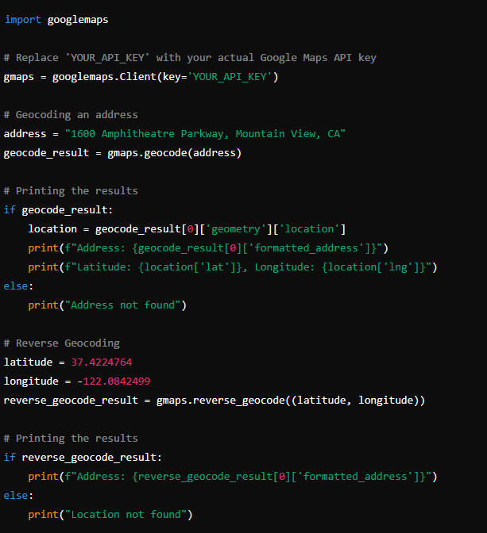**Geocoding and Reverse Geocoding**

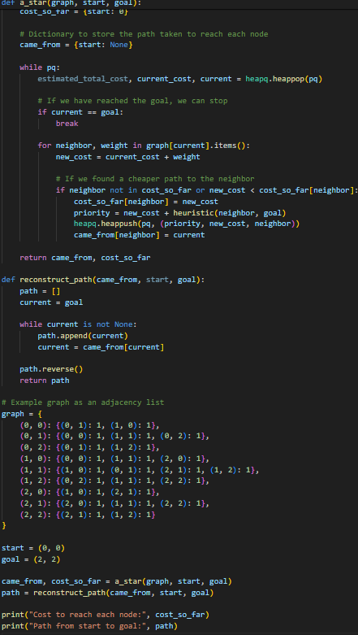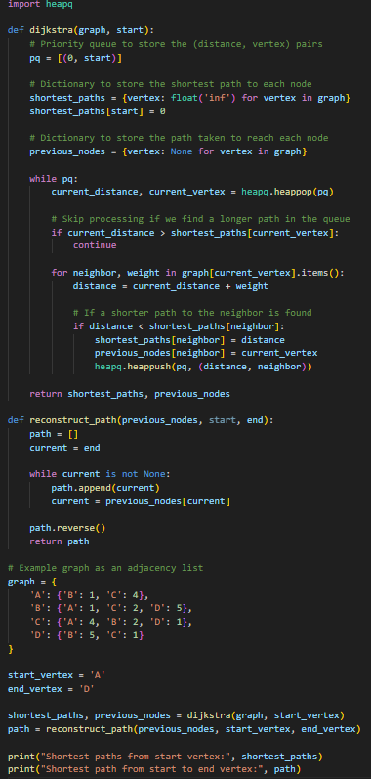

A* Algorithm Djikstra’s Algorithm

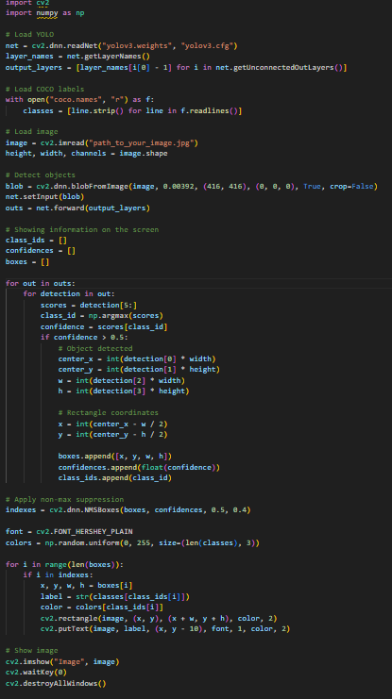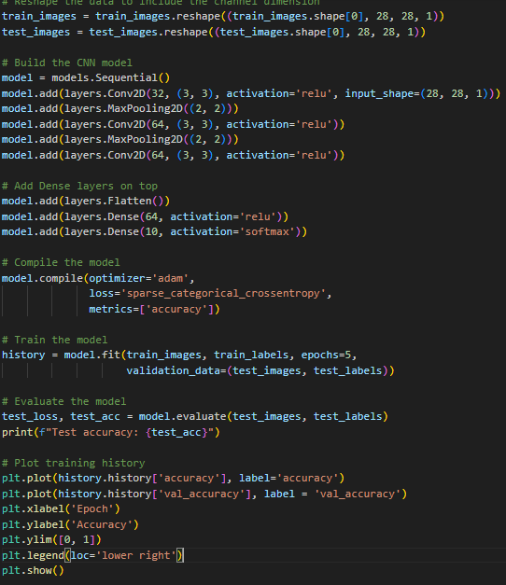

Example CNN model YOLO Algorithm using openCV

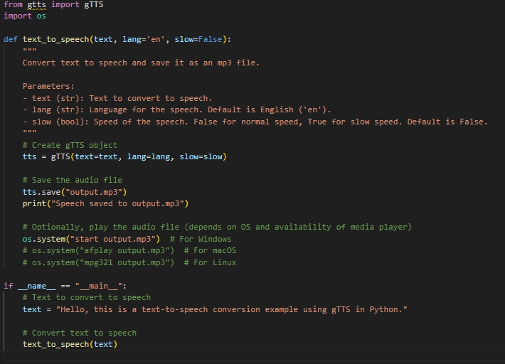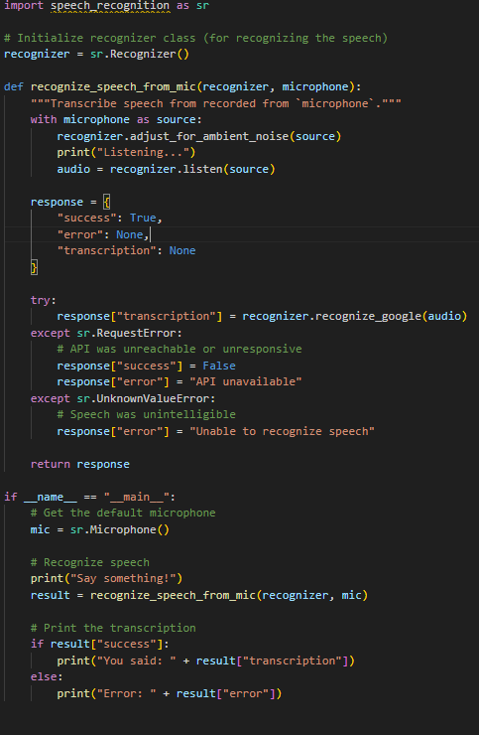

**TTS Algorithm STT Algorithm**

**Note * Google Apis and Libraries such as OpenCV are used in the above codes**

**Conclusion**

The success of Google Maps, Google Lens, and Google Translate lies in the sophisticated algorithms that drive their functionalities. From route optimization and real-time traffic estimation to image recognition and neural machine translation, these algorithms enable seamless and efficient user experiences. As technology advances, these algorithms will continue to evolve, further enhancing the capabilities and accuracy of Google's applications.

**References**

1. Dijkstra, E. W. (1959). A note on two problems in connexion with graphs. Numerische Mathematik, 1(1), 269-271.
2. Hart, P. E., Nilsson, N. J., & Raphael, B. (1968). A formal basis for the heuristic determination of minimum cost paths. IEEE Transactions on Systems Science and Cybernetics, 4(2), 100-107.
3. Krizhevsky, A., Sutskever, I., & Hinton, G. E. (2012). ImageNet classification with deep convolutional neural networks. Advances in Neural Information Processing Systems, 25, 1097-1105.
4. Vaswani, A., Shazeer, N., Parmar, N., Uszkoreit, J., Jones, L., Gomez, A. N., ... & Polosukhin, I. (2017). Attention is all you need. Advances in Neural Information Processing Systems, 30, 5998-6008.
5. Wu, Y., Schuster, M., Chen, Z., Le, Q. V., Norouzi, M., Macherey, W., ... & Dean, J. (2016). Google's neural machine translation system: Bridging the gap between human and machine translation. arXiv preprint arXiv:1609.08144.
6. IEEE Transactions Pattern Analysis and on Machine Intelligence
7. <https://developers.google.com/maps/documentation>
8. <https://cloud.google.com/vision/docs>